* True food patterns

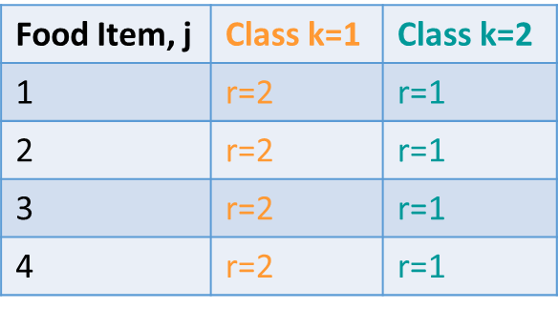

* True outcome probabilities per subpopulation and class

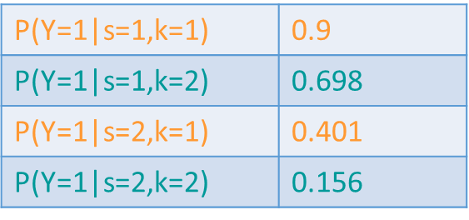

* + Population Iter 1: P(Y=1|s=1,k=1) = 0.8881. P(Y=1|s=1,k=2) = 0.6531
  + Sample Iter 1: P(Y=1|s=1,k=1) = 0.92. P(Y=1|s=1,k=2) = 0.72
  + wsOFMM_latent: P(Y=1|s=1,k=1) = 0.9150. P(Y=1|s=1,k=2) = 0.8417
  + sOFMM_latent: P(Y=1|s=1,k=1) = 0.9219. P(Y=1|s=1,k=2) = 0.8090
* True distribution of classes by subpopulation

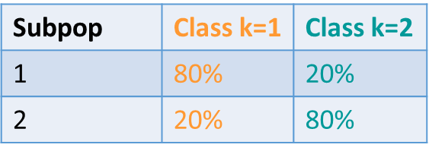

* True population size = 8000
  + N1 = 1000
  + N2 = 7000
* Sample 100 from each subpopulation
  + Weight1 = 1000/100 = 10
  + Weight2 = 7000/100 = 70
* True distribution of pi: (27.43%, 72.58%)
* Sample distribution of pi: (48%, 52%)
  + sOFMM_latent sample distribution for pi: (0.5251, 0.4749)
  + sOFMM_latent predictive distribution: (0.505, 0.495)
  + wsOFMM_latent sample distribution for pi: (0.3144, 0.6856)
  + wsOFMM_latent predictive distribution: (0.465, 0.535)
* True distribution of theta:

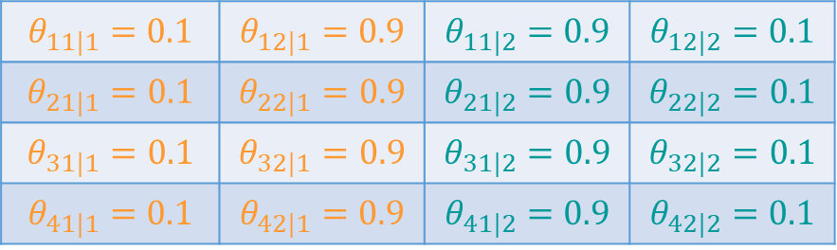

* + When calculated using iter 1

|  |  |  |  |
| --- | --- | --- | --- |
|  |  |  |  |
|  |  |  | 025 |
|  |  |  |  |
|  |  |  |  |

* Sample distribution of theta:

|  |  |  |  |
| --- | --- | --- | --- |
|  |  |  |  |
|  |  |  |  |
|  |  |  |  |
|  |  |  |  |

* + sOFMM_latent sample distribution
    - 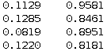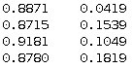
  + sOFMM_latent predictive distribution:
  + wsOFMM_latent sample distribution
    - 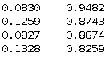 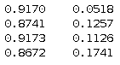
  + wsOFMM_latent predictive distribution:
* True xi iter 1: (1.2, -0.33, 0.08, -0.68)
  + wsOFMM_latent xi: (1.5318 -0.5726 -0.5303 -0.1597)
  + sOFMM_latent xi: (0.7345 -1.3092 0.1396 0.6837)
* Iter 2
* True distribution of pi: (28.29%, 71.71%)
* Sample distribution of pi: (47.5%, 52.5%)
  + sOFMM_latent sample distribution for pi: (0.4881, 0.5119)
  + sOFMM_latent predictive distribution: (0.48, 0.52)
  + wsOFMM_latent sample distribution for pi: (0.3227, 0.6773)
  + wsOFMM_latent predictive distribution: (0.485, 0.515)